ILKIZLER PRESCHOOL
CURRICULUM OF JANUARY

Family
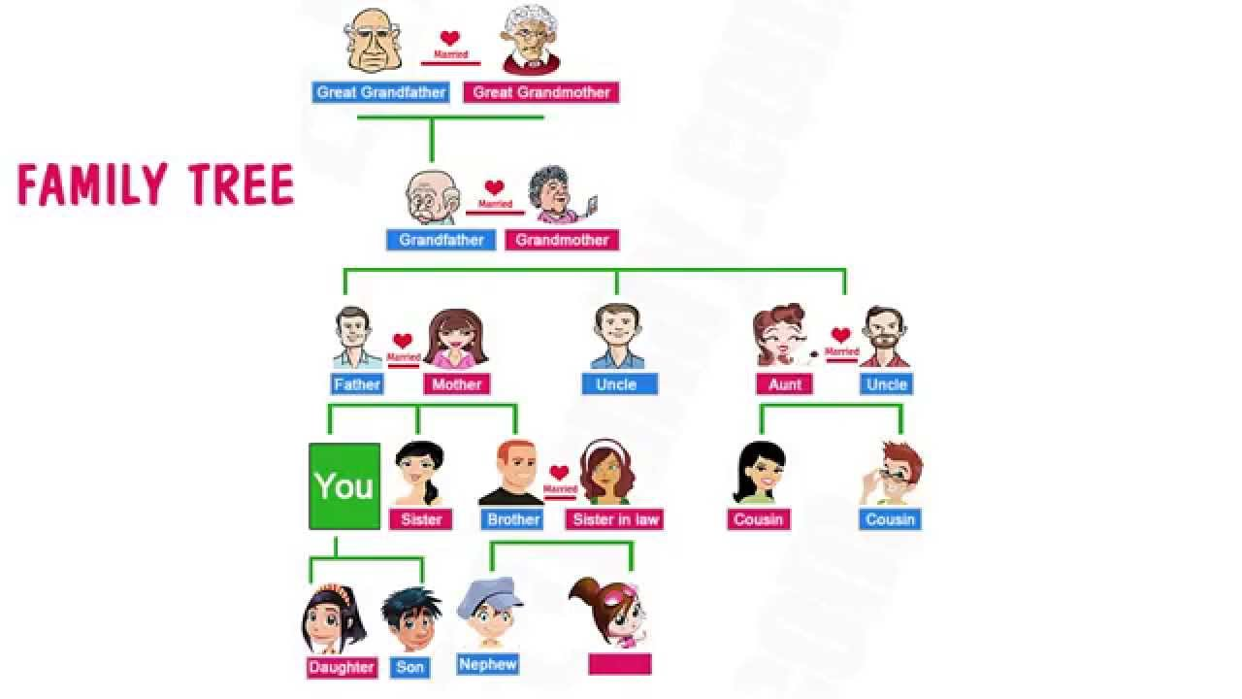
Target words (Hedef Kelimeler)
- Me-ben
- mother-anne
- father-baba
- grandmther-annane,babanne
- grandfather-dede
- sister-kızkardes
- brother-erkek kardeş
- cousins-kuzenler
- aunt-hala,teyze
- uncle-amca,dayı
- baby-bebek

Song:
Finger Family
https://www.youtube.com/watch?v=ZMLW2swx3m0

Introduce your family
My name is ......... Benim adım .........................
My mother name is......... Benim annemin adı..............
My father name is........... Benim babamın adı..............
My grandmother name is.... Benim büyükannemin adı....
My grandfather name is...... Benim dedemin adı............

Cartoon Time
Milo and his Family

This week,we are going to try doing our family tree.
*Bu hafta aile ağacımızı yapmaya çalışağız.
Also
General Remainding-Genel Tekrar
Including
- Family members
- Numbers
- Colours
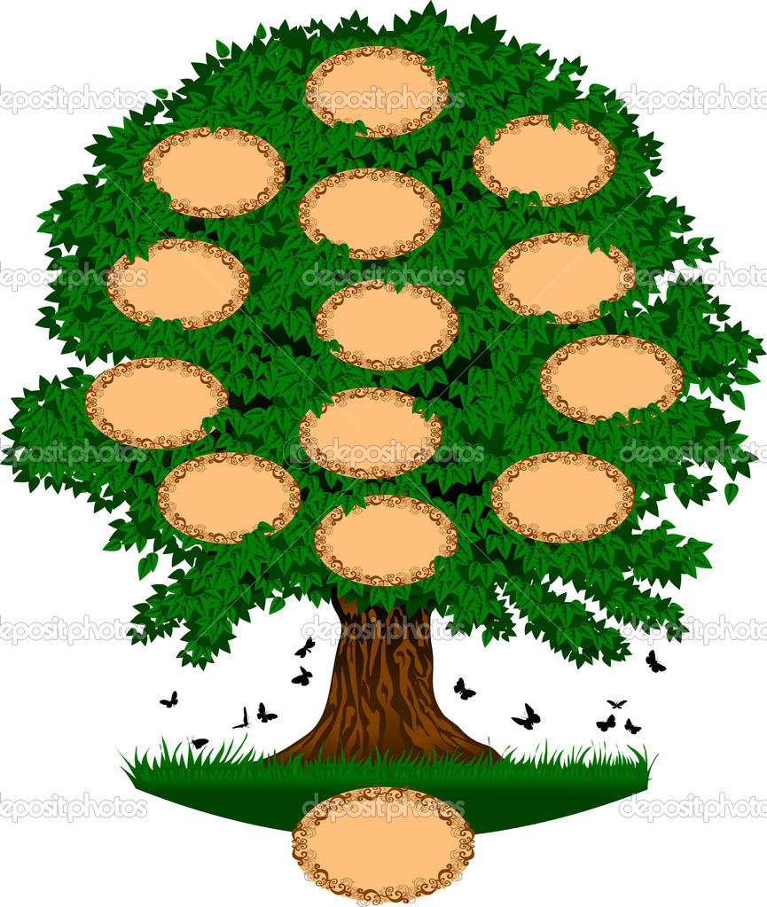

Best Regards
Hilal M.

